IKEA Gifting: Customer Analytics

combine both Years and convert Types safely
select
Invoice , StockCode , Description , Quantity ,

coalesce(
TRY_CONVERT(datetime2 , InvoiceDate,120),
TRY_CONVERT(datetime2 , InvoiceDate,105)
) as InvoiceDate ,
TRY_CONVERT(decimal(10,2),Price) as Price,
Customer_ID , Country , '2009-2010' as SourceSheet
into dbo.RetailCombined
from dbo.[Year 2009-2010]

union all

select
Invoice , StockCode , Description , Quantity ,

coalesce(
TRY_CONVERT(datetime2 , InvoiceDate,120),
TRY_CONVERT(datetime2 , InvoiceDate,105)
) as InvoiceDate ,
TRY_CONVERT(decimal(10,2),Price) as Price,
Customer_ID , Country , '2010-2011' as SourceSheet
from dbo.[Year 2010-2011]

confirm the conversion worked cleanly
select count(*) as Total_Rows from dbo.RetailCombined
select count(*) as Failed_Dates from dbo.RetailCombined where InvoiceDate is null
select count(*) as Failed_Prices from dbo.RetailCombined where Price is null

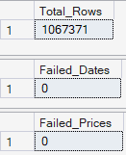

Missing Customer ID
select count(*) as Missing_CustomerID
from dbo.RetailCombined where Customer_ID is null

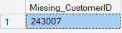

Negetive Or Zero Quantity
select count(*) as Negetive_Qty
from dbo.RetailCombined where Quantity <= 0

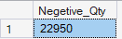

Missing Description
select count(*) as Missing_Description
from dbo.RetailCombined where Description is null

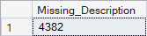

exact duplicate row
select Invoice , StockCode , Description , Quantity , InvoiceDate , Price , Customer_ID , Country ,
count(*) as ExactDupeCount
from dbo.RetailCombined
group by Invoice , StockCode , Description , Quantity , InvoiceDate , Price , Customer_ID , Country
having count(*) > 1

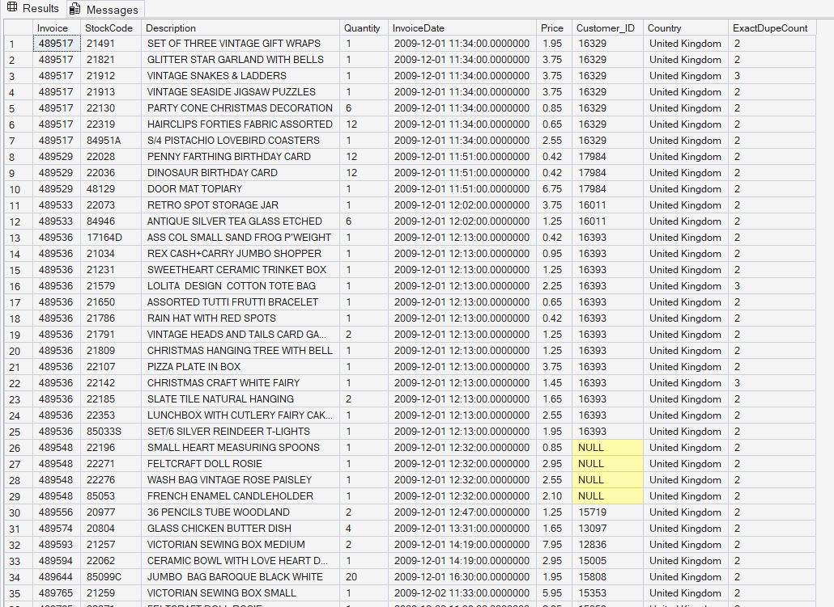

deduplicate and produce the final cleaned table
with cte as (
select * ,
ROW_NUMBER() over (
partition by Invoice , StockCode , Description , Quantity , InvoiceDate , Price , Customer_ID , Country
order by (select null)
) as RowNum
from dbo.RetailCombined
)
select Invoice , StockCode , Description , Quantity , InvoiceDate , Price , Customer_ID , Country , SourceSheet
into dbo.RetailCleaned
from cte
where RowNum = 1

select * from dbo.RetailCleaned New Table
select * from dbo.RetailCombined Old Table

